**9-Sep-2024**

**Internship Day - 37 Report:**

**BGP (Border Gateway Protocol)**

1. It is Routing Protocol.
2. It is Exterior Routing Protocol (Means Autonomous System connect outside).(Rip & ospf is a interior routing protocol which is used inside the company to best path to communicate).
3. It provides Routing between Autonomous System (Big Organization different organization To Connect)
4. ISP (Internet Service Provider Also Used this protocol) in National Level or Regional Level that’s why it is also called routing protocol of internet.

**Who use BGP?**

* ISP
* VERY big Organisations can use BGP
* Having two or more internet Connections have in organization then to communicate we use BGP
* Thats why it is called Multi Homing

**BGP (Border Gateway Protocol) History**

1. Before BGP there is Another Protocol EGP (Exterior Gateway Protocol) but in 1994 BGP v4 Replace the EGP Since 1994 we are using BGP protocol for Exterior Routing Protocol.
2. It also Supports CIDR means classes or internet domain protocols.

**Type of BGP Routing Protocol**

1. it is Neither link state or Distance Vector Protocol.
2. It is called path vector routing Protocol.

**Routing Decision are made Based on**

* Path
* Network Polices
* Rules

**Metric**

1) Very complex & big

2) Composite Metric

3) Tenable with Attributes

If you are not Tenable there attribute according to the polices by default it will be based on Distance vector Protocol, but difference is that there is no of Hops there is a No of Autonomous are there

**BGP (Border Gateway Protocol) Types:**

**i) Internal BGP (IBGP): -** are those BGP Neighbours that belongs to the same AS & These neighbours needn’t to be directly connected. (if they are very close to each other then also connected)

**ii) External BGP (EBGP): -** are those BGP Neighbours that Belongs to the Different AS Neighbours are need to be directly connected

**BGP (Border Gateway Protocol)**

1) BGP Peers and Peering

2) BGP Autonomous System

**1) BGP Peers and Peering:**

1) BGP neighbours: When BGP Router exchange routes with another BGP speaking Device, it is called BGP peer or BGP peering.

2) it is established with the help of by Manuel Conjurations.

**2) BGP Autonomous System**

1) Group of Routers

2) Share Similar Routing Protocols

3) Operate within a single administrative domain.

4) Typically Belong to one Organisation

5) AS Number can be between 1 to 65,535

**LAB 5: BGP (Border Gateway Protocol)**

To implement BGP (Border Gateway Protocol) according to the topology in your diagram, you'll need to configure BGP on the routers in Autonomous System (AS) 20, AS 30, and AS 35.

Here’s an outline of the BGP configuration steps for each router based on your diagram:

**1. Router0 (AS 20) Configuration**

* + **Router ID:** Set the router's BGP process to AS 20.
  + **Neighbor:** Establish BGP neighbor relationships with Router1 (AS 30) and Router2 (AS 35).
  + **Networks:** Advertise the local network 192.168.10.0/24 and 10.10.10.0/24.

Router(config)# router bgp 20

Router(config-router)# neighbor 10.10.10.2 remote-as 35

Router(config-router)# neighbor 192.168.10.1 remote-as 20

Router(config-router)# network 192.168.10.0 mask 255.255.255.0

Router(config-router)# network 10.10.10.0 mask 255.255.255.0

**2. Router1 (AS 30) Conguration**

* + **Router ID:** Set the router's BGP process to AS 30.
  + **Neighbor:** Establish a BGP neighbor relationship with Router0 (AS 20).
  + **Networks:** Advertise the local network 192.168.20.0/24 and 20.20.20.0/24

Router1(config)# router bgp 30

Router1(config-router)# bgp router-id 1.1.1.1 (Compulsory for all router)

Router1(config-router)# neighbor 20.20.20.1 remote-as 35

Router1(config-router)# network 192.168.20.0 mask 255.255.255.0

**3. Router2 (AS 35) Conguration**

* + **Router ID:** Set the router's BGP process to AS 35.
  + **Neighbor:** Establish BGP neighbor relationships with Router0 (AS 20) and Router1 (AS 30).
  + **Networks:** Advertise the local network 10.10.10.0/24 and 20.20.20.0/24.

Router2(config)# router bgp 35

Router2(config-router)# neighbor 10.10.10.1 remote-as 20

Router2(config-router)# neighbor 20.20.20.2 remote-as 30

Router2(config-router)# network 10.10.10.0 mask 255.255.255.0

Router2(config-router)# network 20.20.20.0 mask 255.255.255.0

**Verification Commands**

After configuring BGP, verify the BGP session using these commands on each router:

* Router# show ip bgp summary
* Router# show ip bgp neighbors
* Router# show ip route bgp

These commands will confirm that the BGP neighbors are established and that routes are being advertised and received correctly.

By configuring BGP in this manner, Router0, Router1, and Router2 will be able to communicate across the different Autonomous Systems

**10-Sep-2024**

**Internship Day - 38 Report:**

**Physically Perform In Lab**

**11-Sep-2024**

**Internship Day - 39 Report:**

**HSRP (Hot Standby Routing Protocol)**

In CCNA have only HSRP, VRRP & GLBP is remove

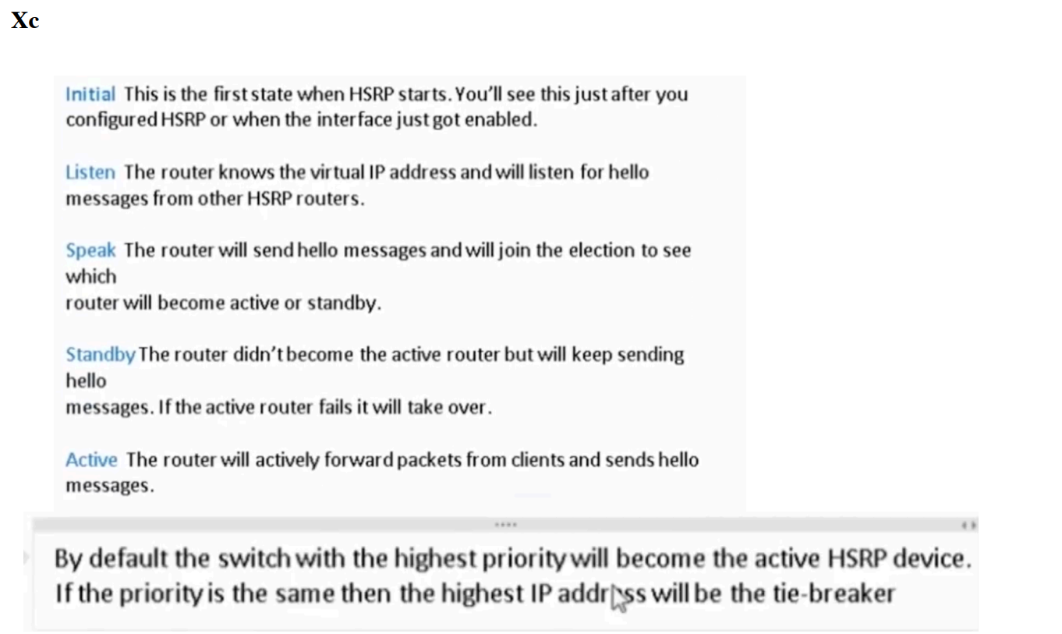

**LAB 6: HSRP (Hot Standby Routing Protocol)**

To implement HSRP (Hot Standby Router Protocol) for your network setup, we need to configure the routers to provide gateway redundancy. Here's how you can configure HSRP on Cisco routers, assuming this is a Packet Tracer or similar topology.

The two routers (Router1 and Router2) in your topology will act as the redundant routers for the clients connected to the switch. I'll provide a basic configuration for both routers.

**Steps to Configure HSRP on Router1 and Router2:**

**1. Configure HSRP on Router1:**

Assume the virtual IP will be 192.168.2.254 for the 192.168.2.x network and 192.168.3.254 for the 192.168.3.x network.

* Router1> enable
* Router1# configure terminal
* Router1(config)# interface fa0/5 # Assuming fa0/5 is connected to the
* 192.168.2.x network
* Router1(config-if)# ip address 192.168.2.1 255.255.255.0
* Router1(config-if)# standby 1 ip 192.168.2.254
* Router1(config-if)# standby 1 priority 110 # Assign a higher priority to Router1
* Router1(config-if)# standby 1 pre-empt # Enable pre-emption so Router1 takes
* over if it becomes active again
* Router1(config-if)# standby 1 version 2 # Use HSRP version 2 for enhanced
* functionality
* Router1(config-if)# no shutdown
* Router1(config)# interface fa0/6 # Assuming fa0/6 is
* connected to the 192.168.3.x network
* Router1(config-if)# ip address 192.168.3.1 255.255.255.0
* Router1(config-if)# standby 2 ip 192.168.3.254
* Router1(config-if)# standby 2 priority 110
* Router1(config-if)# standby 2 preempt
* Router1(config-if)# standby 2 version 2
* Router1(config-if)# no shutdown
* Router1(config-if)# exitRouter2> enable

**Configure HSRP on Router2:**

* Router2> enable
* Router2# configure terminal
* Router2(config)# interface fa0/5 # Assuming fa0/5 is connected to the 192.168.2.x network
* Router2(config-if)# ip address 192.168.2.2 255.255.255.0
* Router2(config-if)# standby 1 ip 192.168.2.254
* Router2(config-if)# standby 1 priority 100 # Lower priority than Router1
* Router2(config-if)# standby 1 preempt
* Router2(config-if)# standby 1 version 2
* Router2(config-if)# no shutdown
* Router2(config-if)# exit
* Router2# write memory
* Router2(config)# interface fa0/6 # Assuming fa0/6 is connected to the
* 192.168.3.x network
* Router2(config-if)# ip address 192.168.3.2 255.255.255.0
* Router2(config-if)# standby 2 ip 192.168.3.254
* Router2(config-if)# standby 2 priority 100
* Router2(config-if)# standby 2 preempt
* Router2(config-if)# standby 2 version 2
* Router2(config-if)# no shutdown
* Router2(config-if)# exit
* Router2(config)# exit

**Verify the Configuration:**

After configuring HSRP, you can verify the status using the following commands:

**Router1# show standby brief**

**Router2# show standby brief**

This will display which router is currently the active router and which one is in standby mode.

**Key Points:**

* 1. **Virtual IP Address:** Both routers will share a virtual IP (192.168.2.254 and 192.168.3.254) that clients will use as the default gateway.
  2. **Preemption:** Allows a higher-priority router to take over when it comes back online.
  3. **Priority:** Router1 is configured with a higher priority (110) to ensure it is the active router.

With this setup, your routers will provide gateway redundancy using HSRP, and clients on both networks will have uninterrupted service even if one router fails.

**12-Sep-2024**

**Internship Day - 40 Report:**

**HSRP (Hot Standby Routing Protocol) Explanation**

HSR Configuring HSRP (Hot Standby Router Protocol) on Router1 involves several steps. Let's break down the configuration, command by command, so you understand the purpose of each part:

**Assumptions:**

• Router1 will act as the primary or active router for the two networks:

192.168.2.x and 192.168.3.x.

• We will use HSRP group 1 for the 192.168.2.x network and HSRP group 2 for the 192.168.3.x network.

• Virtual IP addresses:

* 192.168.2.254 for the 192.168.2.x network (clients will use this as their gateway).
* 192.168.3.254 for the 192.168.3.x network (clients will use this as their gateway).

**Here is the detailed explanation for configuring Router1:**

**Router1> enable # Switch to privileged mode**

**Router1# configure terminal # Enter global configuration mode to apply settings**

**1. Enter Global Configuration Mode:**

This allows you to start making configuration changes on Router1.

**2. Configure the Interface for the 192.168.2.x Network:**

We need to configure the interface that connects to the 192.168.2.x network (which is FastEthernet 0/5 in this case).

* **Router1(config)# interface fa0/5 # Enter interface configuration mode for FastEthernet 0/5P**
* **Router1(config-if)# ip address 192.168.2.1 255.255.255.0 # Assign an IP to this interface**

Here, we assign the IP address 192.168.2.1 with a subnet mask of 255.255.255.0 to the interface. This IP address will be the physical IP address of Router1 for the 192.168.2.x network.

3. **Configure HSRP Group 1 for 192.168.2.x:**

**Router1(config-if)# standby 1 ip 192.168.2.254**

This command configures HSRP group 1 on Router1. The virtual IP 192.168.2.254 is the shared gateway IP that clients will use on the 192.168.2.x network.

This IP address does not belong to any specific router but is used by the active router (Router1 or Router2).

**4. Set Priority for Router1:**

**Router1(config-if)# standby 1 priority 110**

HSRP uses a priority value to decide which router will be active. By default, the priority is 100. We set Router1's priority to 110 so it becomes the active router unless it fails.

**5. Enable Pre-emption:**

**Router1(config-if)# standby 1 preempt**

Pre-emption allows Router1 to take over as the active router if it has a higher priority and if it comes back online after a failure. Without this command, if Router2 takes over as the active router (due to Router1 going down), Router1 won’t automatically become the active router again when it comes back online, unless pre-emption is enabled.

**6. Use HSRP Version 2:**

**Router1(config-if)# standby 1 version 2**This command congures HSRP version 2, which supports IPv6 and offers improved features over version 1. Version 2 uses a different multicast address

(224.0.0.102) and increases the HSRP group numbers range from 0-255 to 0-4095.

**7. Activate the Interface:**

**Router1(config-if)# no shutdown**

The no shutdown command ensures that the interface is active (up) and can participate in the network.

**8. Configure HSRP for the 192.168.3.x Network:** Repeat the same process for the second interface that connects to the 192.168.3.x network (which is Fast Ethernet 0/6 in this case)

Router1(config)# interface fa0/6 # Enter interface configuration mode for Fast Ethernet 0/6

**Router1(config-if)# ip address 192.168.3.1 255.255.255.0 # Assign an IP to this interface**

**9. Save the Configuration:** Once you’ve configured both interfaces, save the configuration to make sure it persists after a reboot.

**Router1(config)# exit**

**Router1# write memory**

This saves the configuration to the router's NVRAM.

**Summary of Key Commands:**

**Virtual IP:** standby [group number] ip [virtual IP] sets the virtual IP address for the HSRP group.

**Priority:** standby [group number] priority [value] sets the priority to control which router is active.

**Pre-emption:** standby [group number] pre-empt enables pre-emption so a higher-priority router takes over if it comes back online.

**HSRP Version 2:** standby [group number] version 2 uses the newer version of HSRP for enhanced functionality.

**Activate Interface:** no shutdown ensures the interface is active and operational. With these steps, Router1 will act as the active router for the clients in the 192.168.2.x and 192.168.3.x networks, providing high availability and redundancy.

**13-Sep-2024**

**Internship Day - 41 Report:**

**Physically perform in Lab.**